How to Create a Static Web Application Using React and Host It on GitHub and Microsoft Azure in a CI/CD Pipeline

Prerequisites:
- Already have an established GitHub and Microsoft Azure account
- A device that can run VSCode or another similar IDE as well as work with larger file sizes and types
- A WiFi connection or wireless hotspot of some sort to connect to the internet
- Have a completed React application that is identical the original tutorial in JavaScript linked here that corresponds with the “Lions, Tigers, and Bears, Oh My!” assignment: https://www.youtube.com/watch?v=AVmGmLFcukM
- Access to this link in GitHub for the full React code (if you just want to learn how to deploy a React app with CI/CD pipeline instead of following the tutorial for JavaScript and recreating it yourself): https://github.com/olivia1117/lions-tigers-bears-react
- Access to this static template on GitHub: https://github.com/EricPogueExampleCode-Web/merna-static-on-azure-2024

Part 1: Create a New Repository on GitHub
- Go to https://github.com/EricPogueExampleCode-Web/merna-static-on-azure-2024
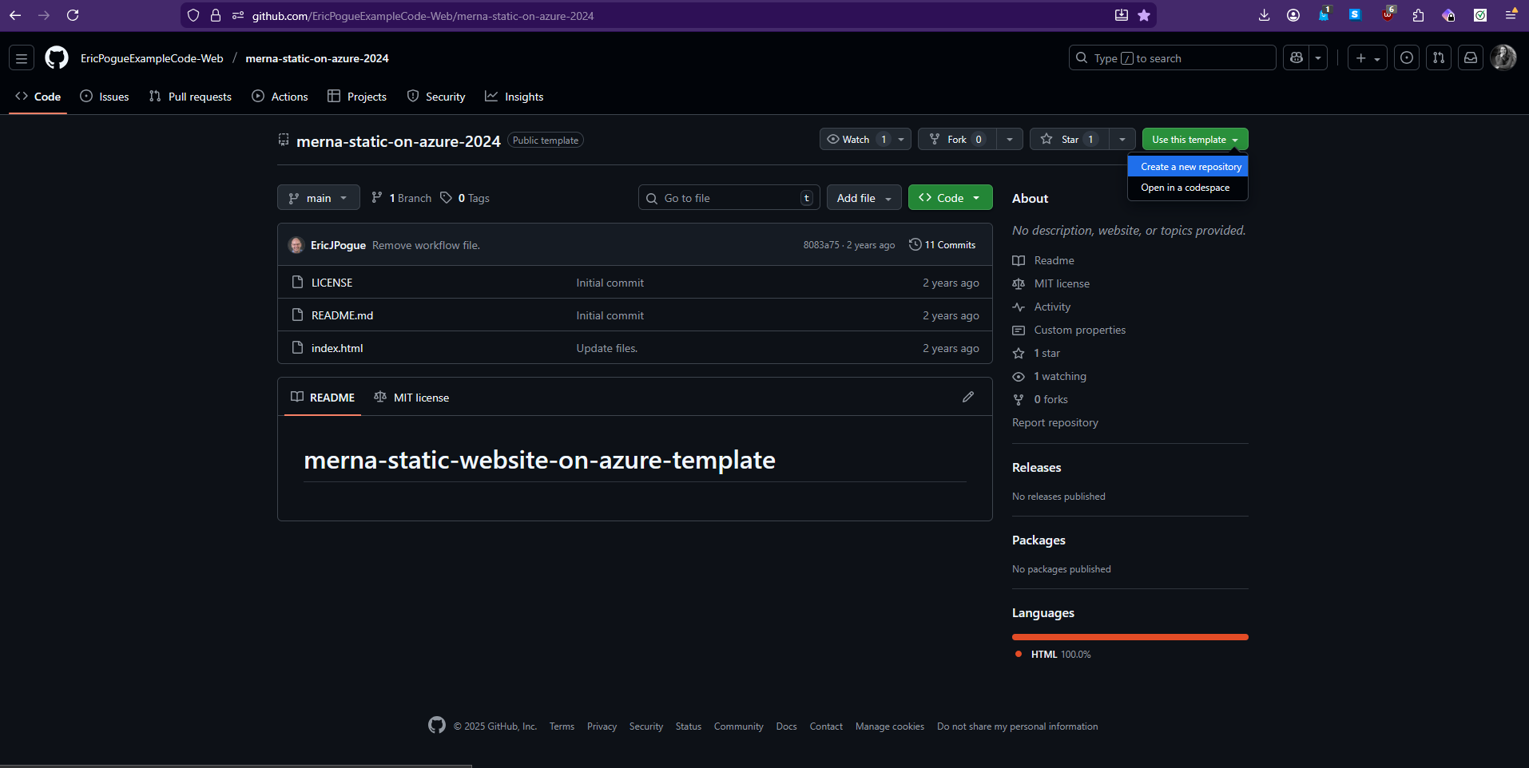
You should see something like this photo above. This is basic template repository that we will be using for this project.
- Then, you will want to select the green button that says Use this template and then select Create a new repository as seen in the photo from step 1.
- You will be taken to another screen and prompted to add a name for the new repository. In this example, I chose lions-tigers-bears-react-2.0 since it’s available in green which means I don’t have another repository on my account with the same name.
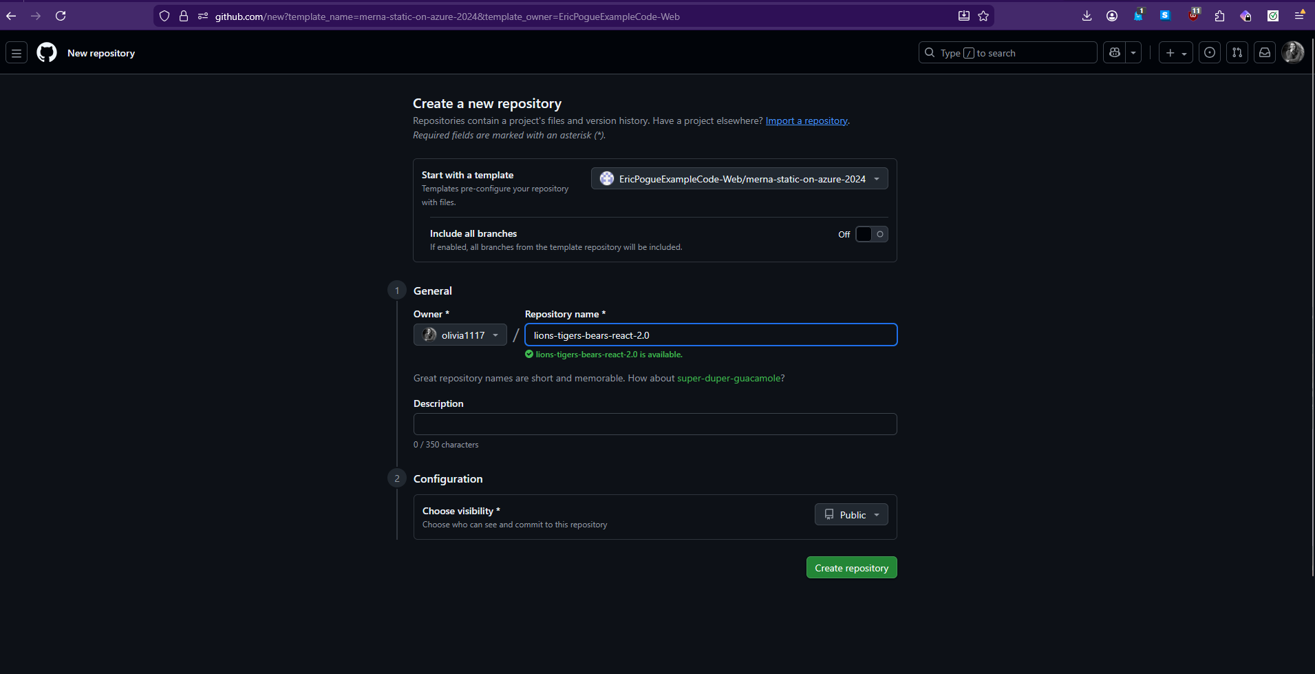
Make sure your visibility is marked as public at the bottom and then click on the green button that says Create repository.
- Once the new repository is generated, you should see a screen that looks like this:
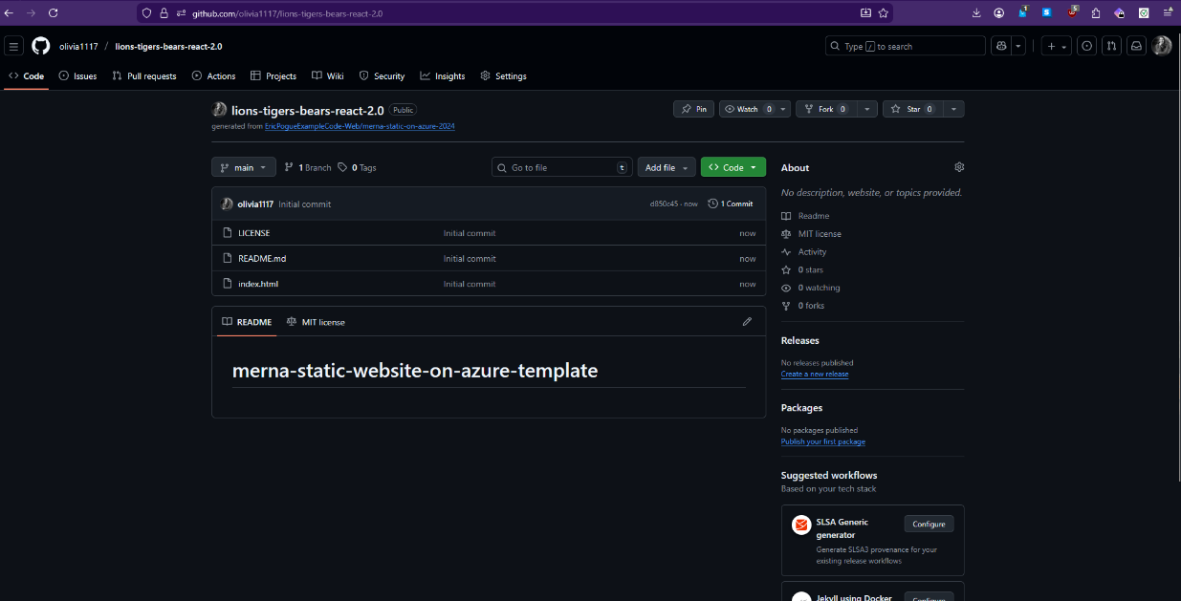

Part 2 – Cloning the Repository to Local Machine
- Next, we can clone this repository to our local machine where we can then further develop and add onto this repository and test any changes before pushing it back to this version on the web. In order to do this, we can click on the green button that says Code and then ensure we can see the HTTPS address selected before clicking on the two overlapped squares icon to copy the address.
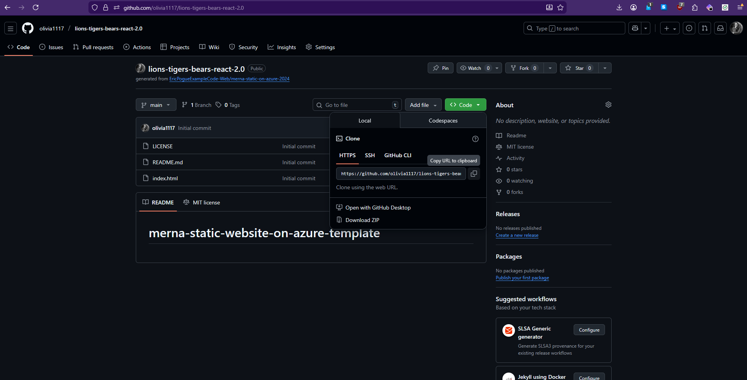
- Now, you will need to open your terminal for this next step. I opted to download, install, and use the Git Bash terminal because I feel most comfortable with that. If you choose to use something different, you may need to look up the commands for that particular terminal.
- Once you have your terminal open, make sure you know which folder it corresponds to on your machine. I have mine set up so that the main folder it brings up every time is my user folder on my C drive. Yours will probably look a little different and that’s okay. Just make sure you know where you will be cloning your repository. Type the command git clone and then paste in your link and hit enter. You should see the command activating like the second picture.
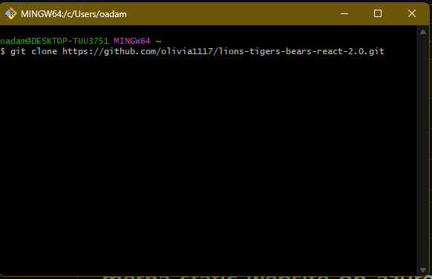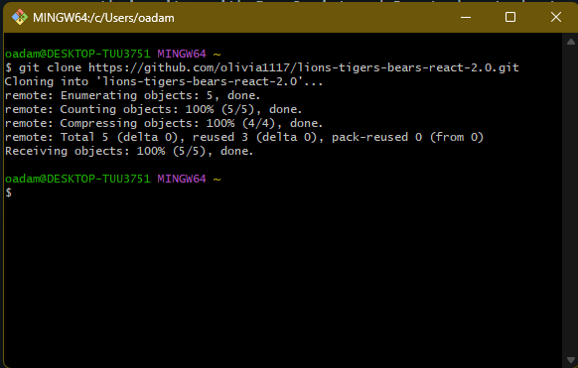

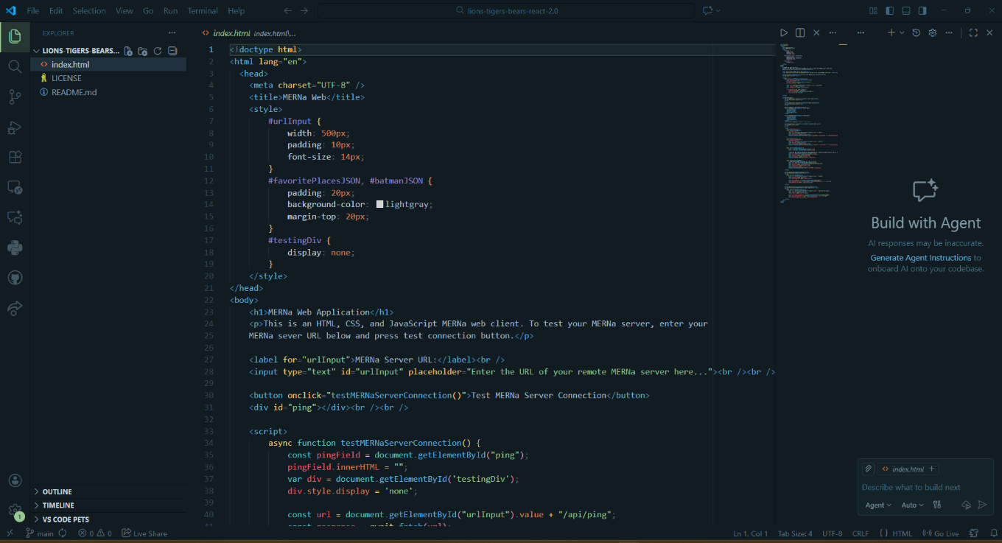
- Once that is done, open up VSCode or another IDE of your choice and open up your folder where you stored the repository on your machine. It should have the same name for example, lions-tigers-bears-react-2.0 for this instance. Open up some of the different files in here and take a look around. If you paid attention, you should notice that it has all of the same files as the version on the web that we cloned from. In this picture, I just opened up the html to take a look at it.

- Now we can go to this other repository with the React code already completed for this tutorial (if you chose to follow the original JavaScript tutorial and converted it to React instead, that’s completely fine. In that case, you can just copy over the same files, but from your repository instead).
Link to lions-tigers-bears-react repository: https://github.com/olivia1117/lions-tigers-bears-react
When you open the link in a separate tab, you should see something like this:
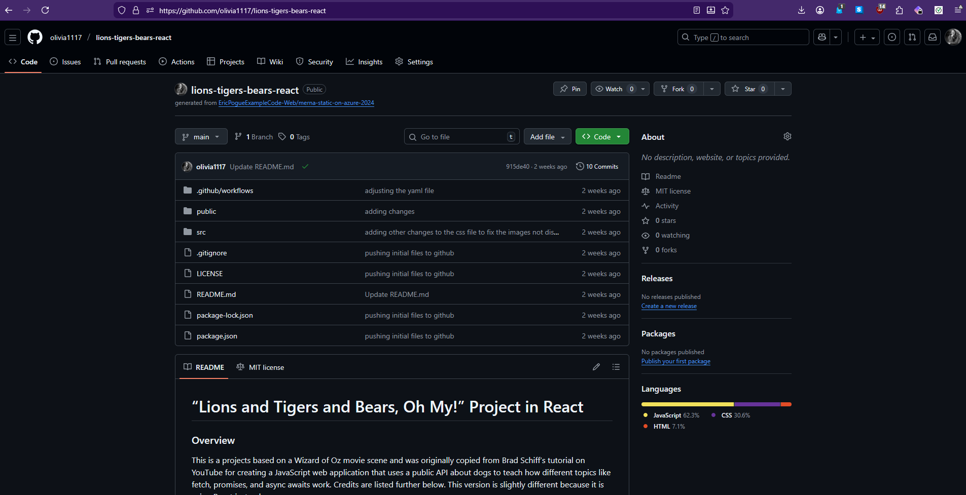
From there, you will want to copy the structure and files seen here. For example you will want to create a new folder in your local repository called src and then copy the contents from the src folder on the web containing App.js, index.js, and main.css by opening each file and copying and pasting the content into the local machine with files of the same names.
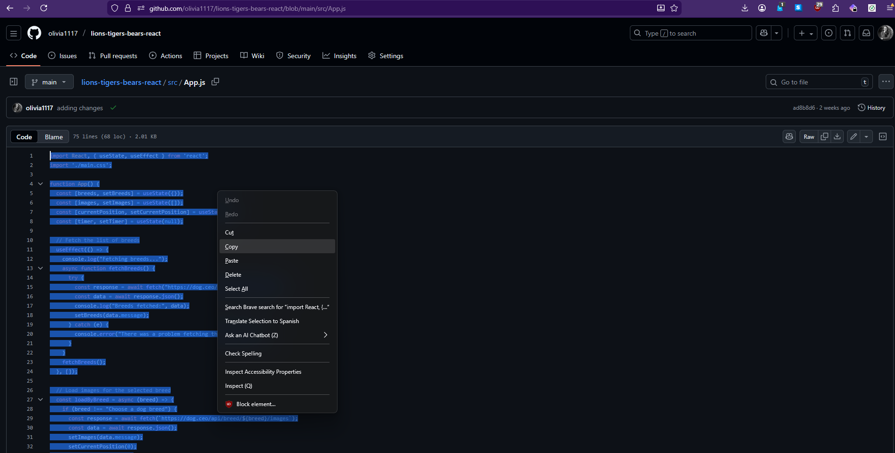
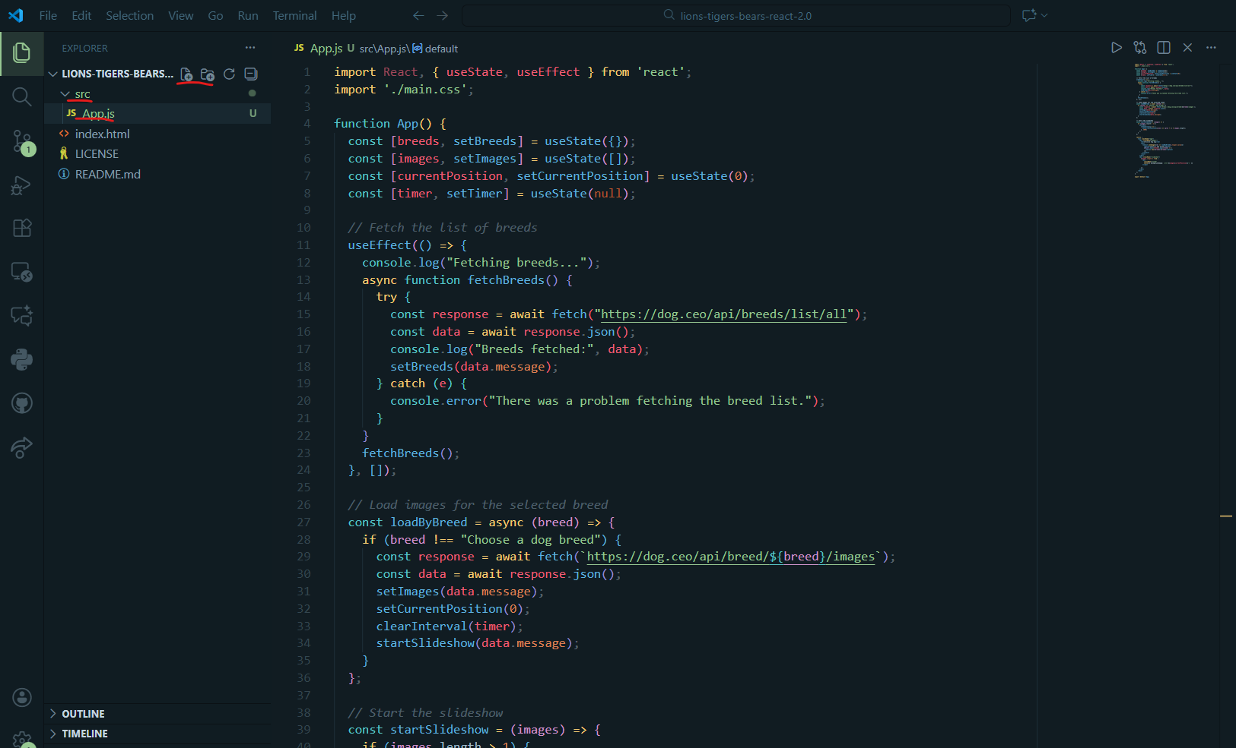
Repeat this process for the other folders and files until you have a local repository that looks like the picture below (also note, I deleted the original index.html file and then made a completely new one using the copy and paste from the online repository of the created application and put it in the public folder):
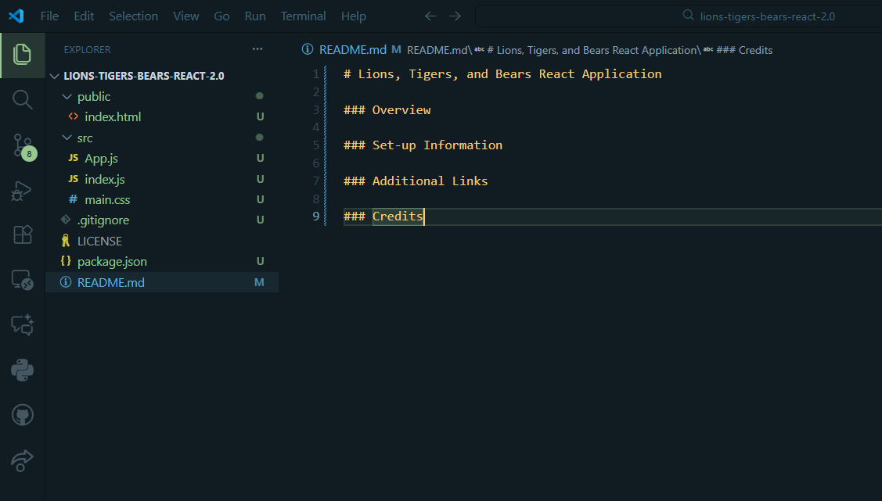
Also note: I edited the README file to give some ideas of various headers to include with information for you to fill in under them. I would advise you to fill this out so that way anyone looking at your repositories in the future can get a better idea about what you developed, see your progress as a developer, and then also see that you are competent with creating helpful documentation and giving proper credit.

Part 3 – Testing the Application Locally
- Now that we have everything here for local development built, we should test it locally just to make sure that it runs well on our end. This is crucial to do because in a real-world scenario, if you don’t test your code locally as well as conduct other tests before putting it into production, it could take down servers, websites, applications, etc and it would be a very expensive and time-consuming lesson to learn and to put your other coworkers through. Testing is important. Do not neglect it.

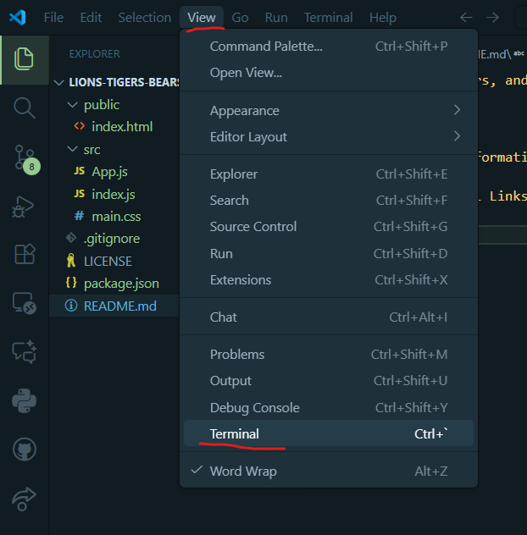
In order to test this locally, we can click on View at the top of the page in VSCode and then find the terminal option:
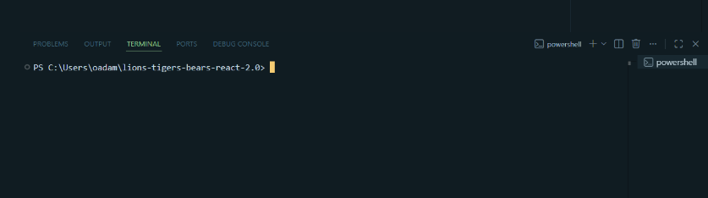

You should see a basic PowerShell terminal pop up and if not, you may have to reconfigure your VSCode settings to make that the default.

- If this is your first time building a React app, you’ll have to run the command npm install and hit enter
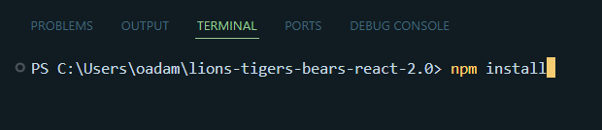
It might look a little crazy with a bunch of different things loading, but just wait until it’s done. When it is done, it should just show the command line open again. Then, you’ll want to run the command npm start
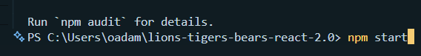

This will take a second, but ultimately, it will open a new tab on your default browser at http://localhost:3000 where you can view what you have added into the repository and test it without it going into production first. Take some time here to play around with the current application and see what’s going on. Another thing to note is that if this isn’t working, you may already have the port 3000 used on your computer at the moment or for another purpose. You may have to change the default port for testing in VSCode settings to something that is free. Ultimately, the web version should look something like this:
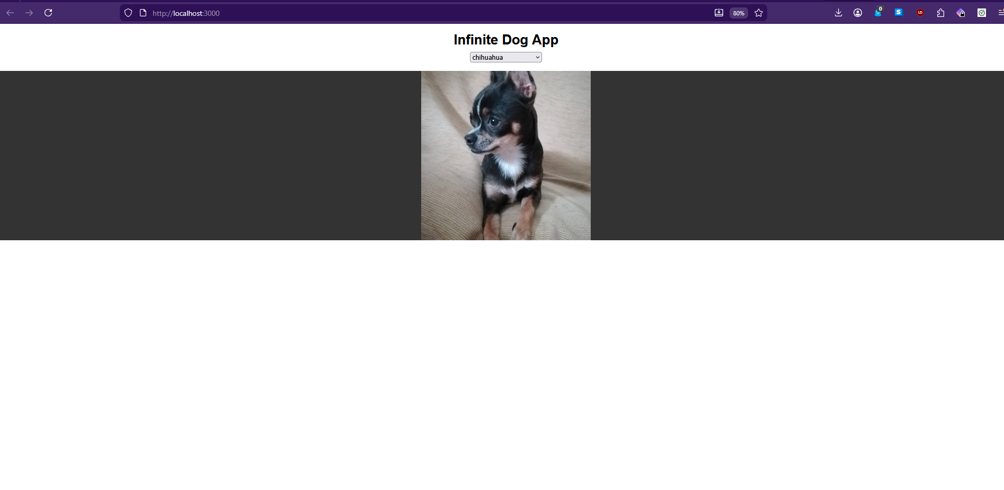

Part 4 – Setting Up the Azure Page for Hosting
- Once you’ve tested everything appropriately and everything works, we’re going to pivot towards setting up our Microsoft Azure site to host it in a moment. When you’re ready, go to https://portal.azure.com/auth/login/

Then if you already have an account, you should have some sort of home page like this:
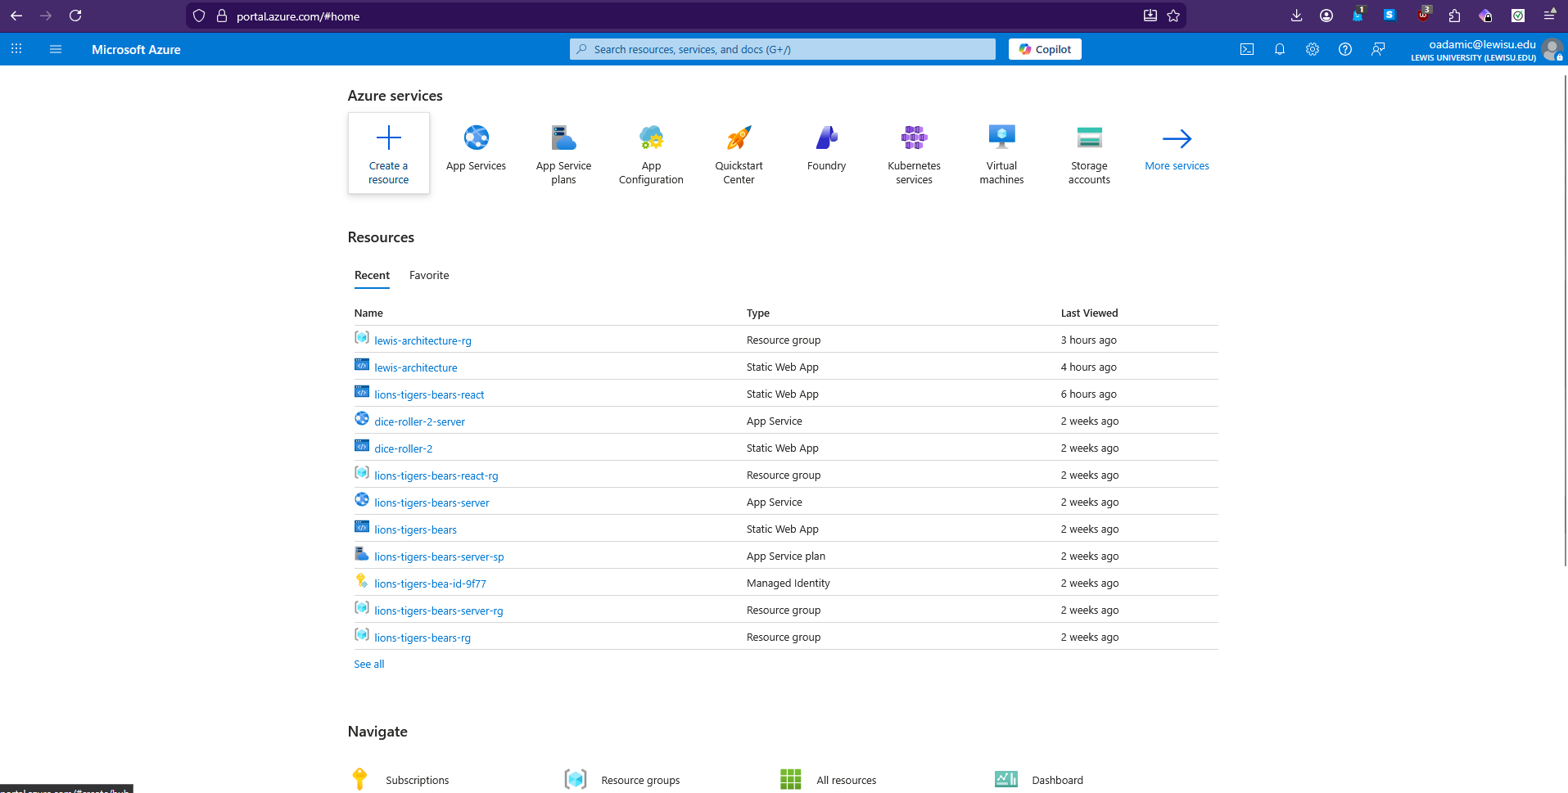
Then you want to click on Create a resource and search for Static Web App
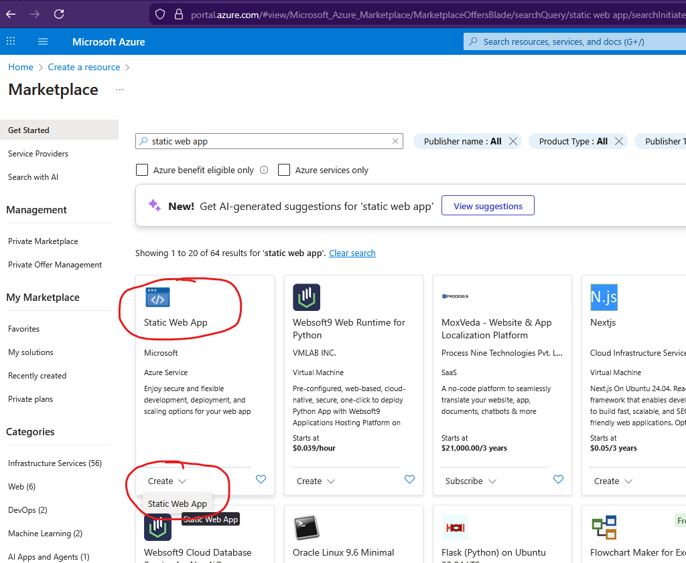

- Now you want to select a free subscription plan and create a new resource group. Try to match the name of the resource group with what you will named the static web app and then add rg to the end so you can tell the two apart like so:
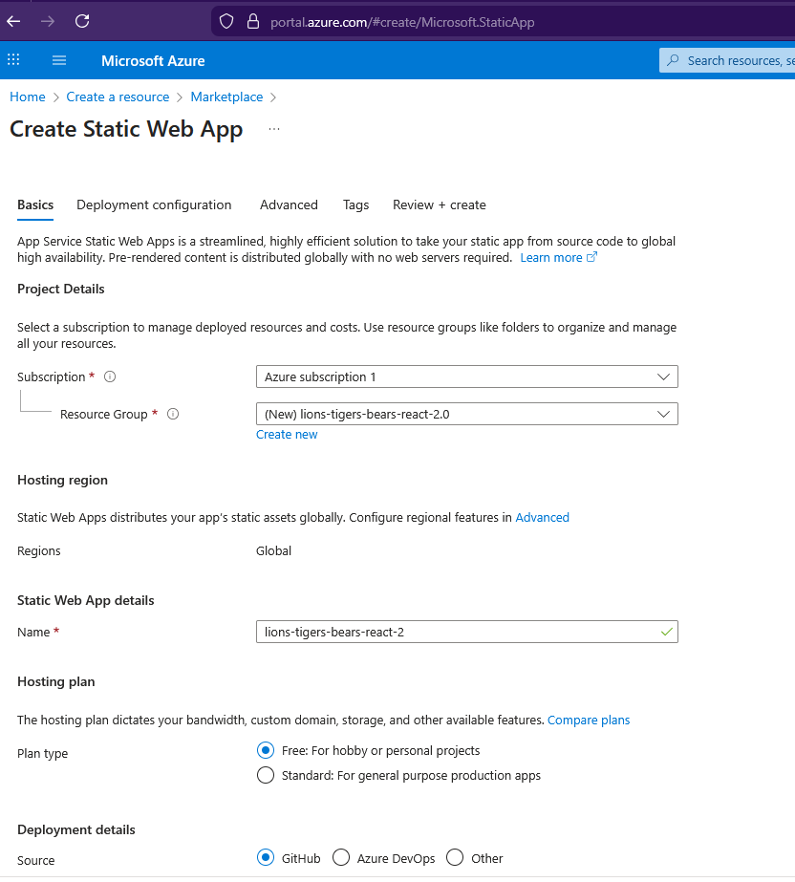
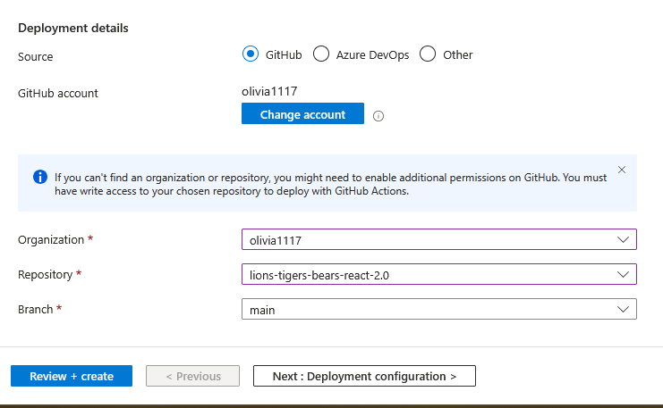

- Then you also want to select your GitHub username for the Organization, select the name of the repository you made on GitHub and then leave the Branch as main. Now go to Deployment and configuration. Leave these settings alone. On the Advanced tab, choose the region closest to you. Then leave the Tag settings alone before reviewing and clicking the Create button:
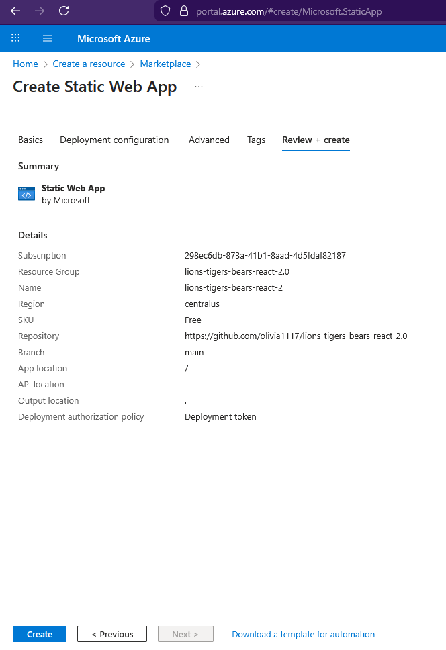

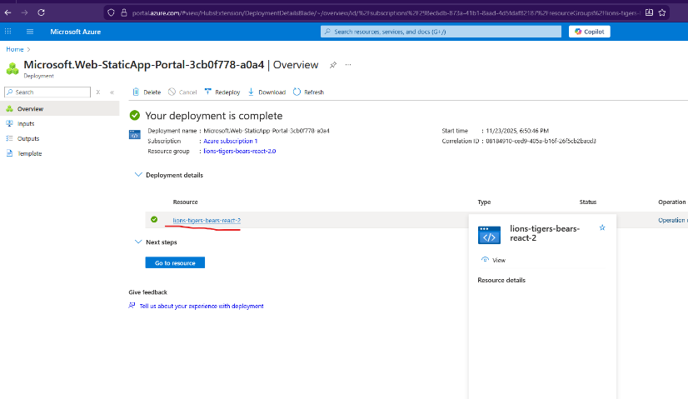
- Once you click Create, the deployment will be initialized and then you can click on the resource under Deployment Details:

- Then you can visit the site you just made by clicking the link:

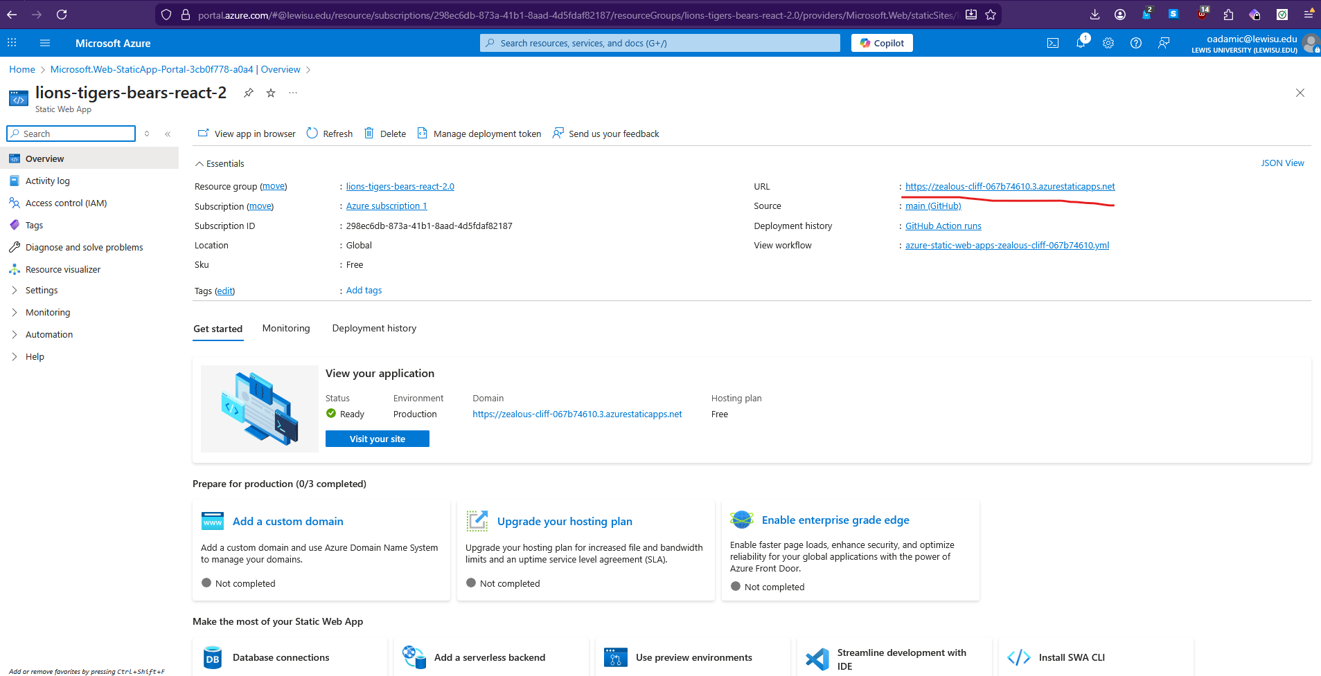

- If you visit it now, it will still probably load the old HTML file with the MERNa Web Application header. That’s okay because that means we haven’t pushed any of our new content yet. Let’s go back to our VSCode application to do that now since we finished our testing.

Part 5 – Building and Pushing from Local Repository to Online Version
- Now we can make a new PowerShell terminal and then run the command
npm run build
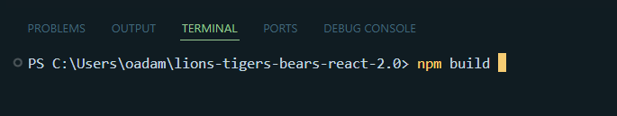

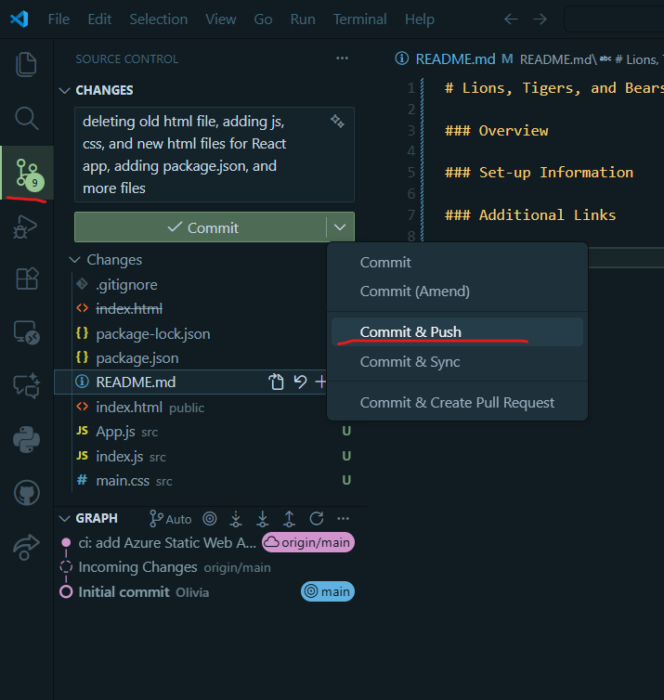
- Now, you can go to the Source Control icon on the left side and fill in a commit message. You should see a list of all the files that were created, updated, deleted, etc. The commit message is a way to keep track of what you did between the local and the web version and is particularly useful when working with teams when there are multiple changes being made per person per day or hour. Once that’s filled out, then click the drop down and select Commit & Push
- What happens now is that the changes from your local machine will be pushed to the web version so that it is accessible publicly and to your team if you have one. Sometimes, it may say you need to sync some changes first, so just go through that process if necessary.
- Now you can go to your GitHub repository and click on the Actions tab. On this view, you’ll see a new workflow running in orange which are all of the files you just pushed trying to now be implemented through the GitHub and to the Azure site:
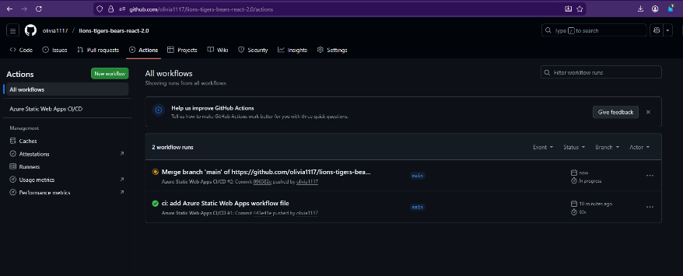
- If the build failed, you might see a red X and an explanation. What you may have to do to fix this is go back to VSCode and then go to your new workflow folder here:
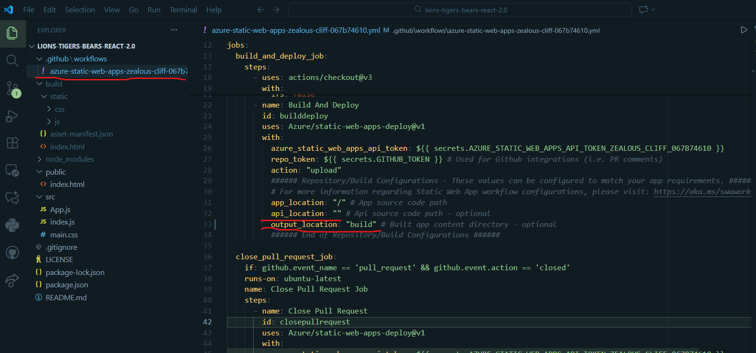
More than likely, you just need to set the api_location variable to an empty string value and the output_location to “build”. Then go and write a commit message in the source control again and push it like you did previously. If you go back to GitHub Actions online, you should see your new push:
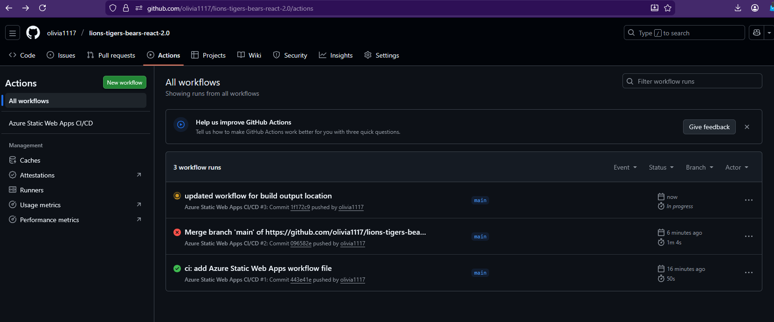
- If it keeps showing orange for a while, just click on the name of the commit message and it might turn green meaning you’re all good to review your Azure page! Go back to the page you opened that you made from Azure and maybe it refresh it first. Then you should see what you saw in your local testing appear:
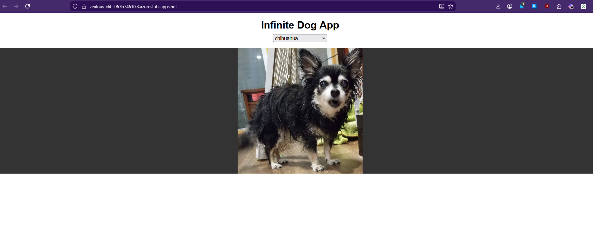

- At this point, you should be all set! You have successfully used GitHub and Azure to test, deploy, and host a React application!

